Brothen Matthew

Unit 6 Exercise 3 6 and 13

Exercise 3:

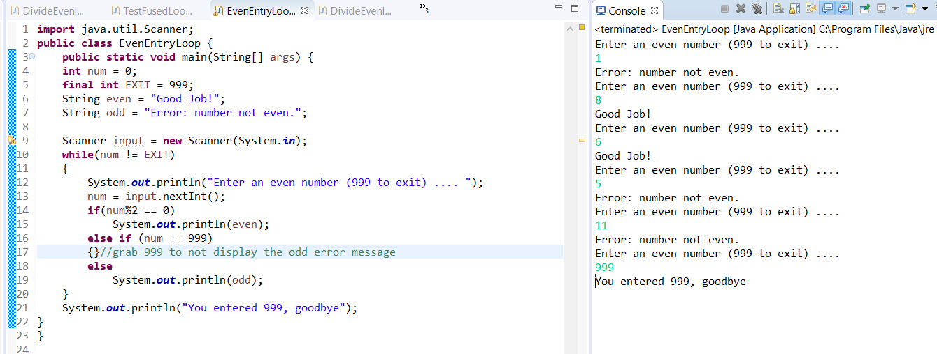

Perfect Numbers:

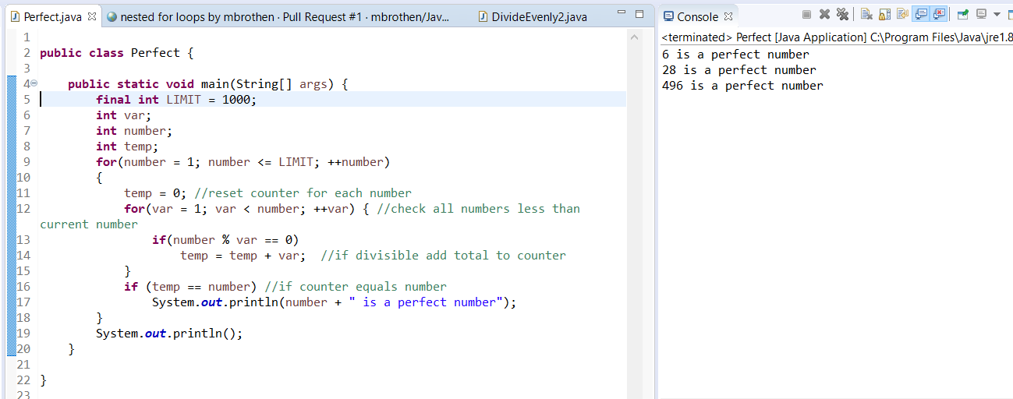

BarChart:

This could be much shorter if we were using lists already.

